

Section 9, Team 2:

­ Imani Malone

Keith Martin

Brent Moore

Zachary Parker

Kirsten Redmond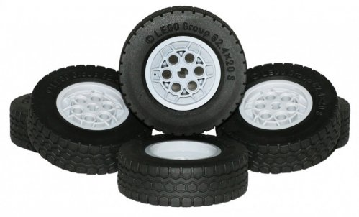

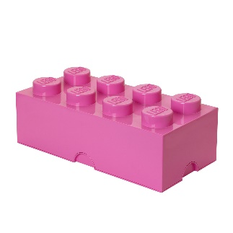

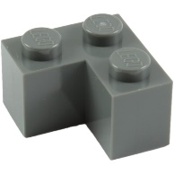

ENGR 1110 – Dr. Roppel

Spring 2016

Submitted 4/23/2016

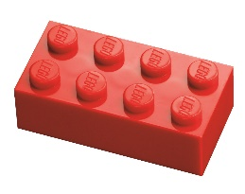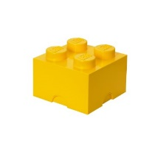Auburn University

**Executive Summary**

This report discusses our creation of a motorized LEGO vehicle, as well as the decisions we made in order to develop an overall efficient and effective product. We raced this car along a track that involved maneuvering through three gates and pushing a small block to the finish line. Using the parameters provided, we produced a car whose most prominent trait is its structural simplicity and clear-cut design.

The base is a simple square large enough to hold the various components, such as the motor control board and batteries, along with a front piece designed to make pushing the block easier to accomplish. The car employs front-wheel drive using two motors to maximize ease of control, with non-motorized wheels in the back. We used resistors that would get us as close to a 10.0 volt output as we could reasonably obtain, and we also chose to use two 9 volt batteries in series as our voltage input (one battery for each motor).

With these various design decisions, we created a car that would be easy to maneuver, simple to adjust (if necessary), and sturdy in its design, all while remaining formidable in terms of voltage output and speed.

**Table of Contents**

Introduction…………………………………………………………………………………...4

Problem Statement…………………………………………………….……….………….4

Design Overview………………………………………………………….………………4

Technical Sections…………………………………………………………………….……6

Power Supply…………………………………………………………….………………..6

Wheel Size………………………………………………………….……………………..7

Driving Strategy………………………………………………………….………………..8

Course Path………………………………………………………………………………..8

Car Body Design…………………………………………………………………………..9

Output Voltage…………………………………………………………………………...10

Budget……………………………………………………………………………………11

Performance……………………………………………………………………………...11

Conclusion…………………….……………………………………………………….…….13

Appendix………………………………………………………………………………..……14

**Introduction**

We were given the task of designing and constructing a motorized LEGO car. We were to purchase all of the LEGO parts necessary, the motors, as well as resistors and batteries. Once our team had successfully completed our car, we were to test it out in a race. The race consisted of a time trial with three gates and a block. The goal was to get the fastest time in 3 runs. Each gate in the race was necessary to pass through unless the team wanted a time penalty. The last task was to push a block across the finish line, and failing to do this would result in a substantial penalty of thirty seconds.

Our team had no previous knowledge on this subject matter or how we could go about completing this task. None of us had ever dealt with motorized LEGOs before. Throughout the labs and assignments involved in this course, we gained more knowledge on the task at hand until we were able to successfully build a functioning motorized car.

Our approach began with buying a basic LEGO car kit. From that basic car, we built onto it and removed portions in order to provide room for the motors, batteries, RC transmitter, and motor control board. The configuration that best achieved this was a flat square surface with a front portion. The front portion – a series of long horizontally-oriented pieces combined with an outward-facing piece on the right side – provided a means of keeping the block secure while it was pushed through the finish line.

We then assembled the electrical aspects and performed test runs. We connected two 9V batteries to the motor control board. Then, we connected the motors to the motor control board as well as the RC transmitter. We also connected our chosen resistors that would provide a voltage output close to 10 volts. Finally, to complete the setup, we ensured that the transmitter was correctly connected wirelessly to the receiver so that we could control the car without fail.

The remainder of this report outlines the technical portions of our choices and design. The technical section includes the tradeoffs regarding the design and effectiveness of the car. These tradeoffs are presented in the form of various Pugh charts. The section also includes the numerous alternatives that were considered and reasons for our choices. The technical section features data collected and observed within the design process along with photos, charts and figures. It also shows the details of our budget for this project. The technical section is followed by the conclusion and appendix.

**Technical Sections**

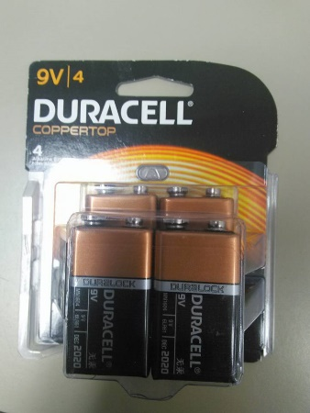For our power supply, our options included one 9V battery, two 9V batteries, or lithium batteries. Critical areas for the power supply were longevity, weight, power and potential penalty. The 9V batteries had a clear advantage in terms of longevity, but the watch batteries were excellent for keeping weight at a minimum. However, the added weight of the 9V batteries was not an obvious disadvantage, as our already bare-bones design could make use of extra weight. The 9V batteries also had a clear advantage regarding power, the only tradeoff with that being that two 9V batteries could incur a penalty. In the end, we decided that two 9V batteries would work best with our car design. We also chose to connect the batteries in series to generate a total of 18 volts, allowing our input to deplete all the way to approximately 10 volts before replacement batteries were needed.

|  |  |  |  |  |
| --- | --- | --- | --- | --- |
| Power Supply | | | | |
| Criteria | **Importance** | **One 9 Volt** | **Two 9 Volt** | **Lithium Batteries** |
| Longevity | 3 | + | ++ | -- |
| Weight | 1 | 0 | - | ++ |
| Power | 3 | + | ++ | - |
| Potential Penalty | 2 | ++ | 0 | ++ |
| Weighted Scores |  | 10 | 11 | -3 |
| Design Choice |  |  | X |  |

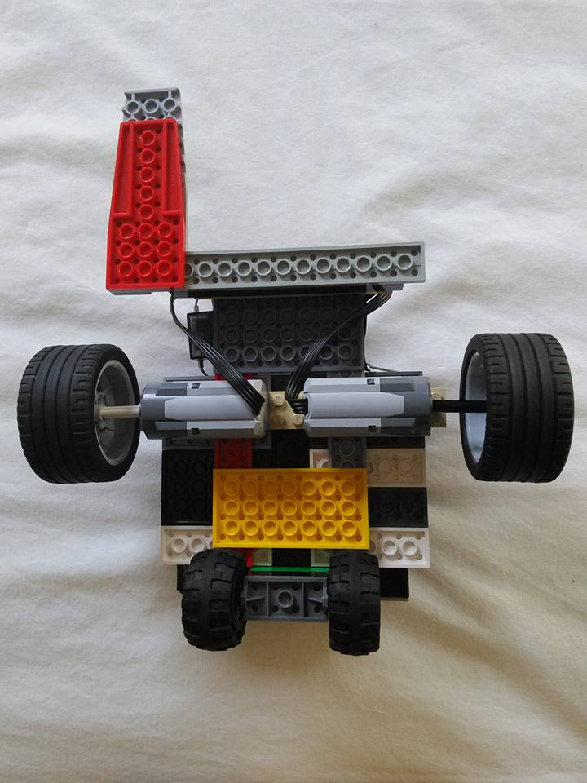Our next decision was to choose the type of wheels that would work the best with our car. Our options included large front wheels, all medium wheels, or all large wheels. Our large wheels would have a diameter of 56mm and a width of 28mm, while our medium wheels would have a diameter of 37mm and a width of 18mm. The critical areas to consider were grip, speed, and cost. Although we first believed that medium wheels would yield a higher overall speed due to a higher rotations per second, it became clear that large wheels were going to net a higher speed due to having a higher torque. Additionally, having larger front wheels would increase the grip of the car. However, this increase in grip diminished when large wheels were also placed in the back; this is where medium wheels were sufficient, as they only needed to act as support. Because the medium wheels were already on hand, and the larger wheels needed to be purchased in addition to our current assets, the cost of these new wheels was also considered. However, because the cost was not considered highly, our best option in the end was to use motorized large wheels in the front and medium support wheels in the back.

|  |  |  |  |  |
| --- | --- | --- | --- | --- |
| Wheel Size | | | | |
| Criteria | **Importance** | **Large Front Wheels** | **All Med. Wheels** | **All Large Wheels** |
| Grip | 3 | ++ | 0 | + |
| Speed | 2 | + | 0 | ++ |
| Cost | 1 | - | ++ | - |
| Weighted Scores |  | 7 | 2 | 6 |
| Design Choice |  | X |  |  |

Drivetrain is important to consider when building a car. The decision was evidently between rear wheel drive and front wheel drive. Controllability and stability were the two important areas to consider, each with their advantages and disadvantages. Rear wheel drive provides better stability overall, but we decided that controllability would be vital during the race in order to ensure that we pass through all of the gates and push the block in an accurate way. Because front wheel drive would provide this level of controllability, we chose this method.

|  |  |  |  |
| --- | --- | --- | --- |
| Driving Strategy | | | |
| Criteria | **Importance** | **Front Wheel Drive** | **Rear Wheel Drive** |
| Controllability | 2 | ++ | 0 |
| Stability | 1 | 0 | ++ |
| Weighted Scores |  | 4 | 2 |
| Design Choice |  | X |  |

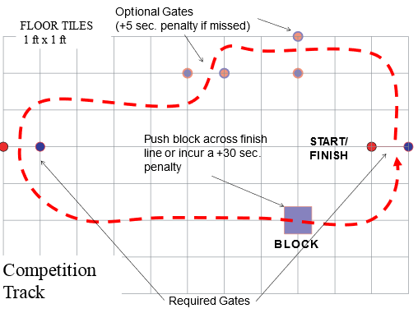When considering the parameters and layout of the racetrack, it is important to decide which of the four possible options to take. In terms of our options, we could either choose to pass through all gates and push the block, pass through all of the gates but not push the block, miss the optional gates and push the block, or miss the optional gates and not push the block. We had critical areas of time penalty, likelihood of completing, and likelihood of our car surviving. Passing through all of the gates with the block does not incur a penalty, making this the theoretically optimal strategy. However, we are the most likely to complete the race without passing through the optional gates or pushing the block. We have concluded that our car has a high percentage chance of surviving through the track due to its fundamentally sturdy design, so we have decided to try and go through all gates and push the block in order to minimize time penalties and obtain the best time possible.

|  |  |  |  |  |  |
| --- | --- | --- | --- | --- | --- |
| Course Path | | | | | |
| Criteria | **Importance** | **Pass Through All Gates and Push Block** | **Pass Through All Gates and No Block** | **Miss Gates and Push block** | **Miss Gates and Miss Block** |
| Time Penalty | 3 | ++ | - | 0 | -- |
| Likelihood of Completing | 2 | - | 0 | 0 | ++ |
| Car’s likelihood of survival | 2 | + | ++ | + | ++ |
| Weighted Scores |  | 6 | 1 | 2 | 2 |
| Design Choice |  | X |  |  |  |

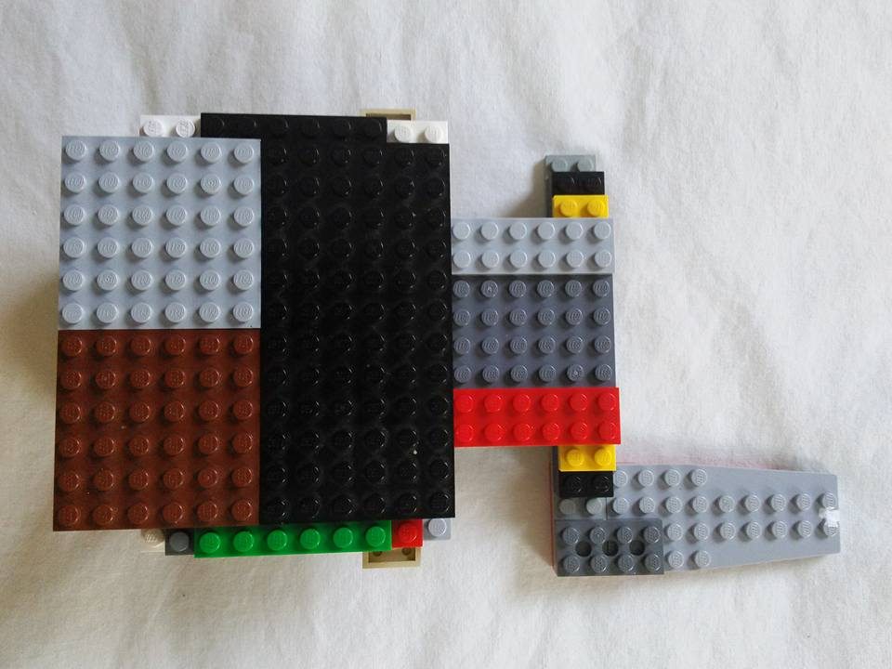We had three different body types to choose from. We could either choose a light, medium or heavy frame. These criteria are based on the weight of the car rather than surface area, as weight is what ultimately determines how well the car will push the block at the end of the course. In debating which to use, we considered speed, ability to push the block, and maneuverability. The light body obviously has the greatest speed advantage with heavy having the worst, but the heavy and medium cars are more likely to be effective in pushing the block. The light car also has the edge in maneuverability, but because we value the ability to viably push the block so highly, so we decided on the medium design. This gives the car a balance of both speed and block-pushing ability.

|  |  |  |  |  |
| --- | --- | --- | --- | --- |
| Body | | | | |
| Criteria | **Importance** | **Light** | **Heavy** | **Medium** |
| Speed | 2 | ++ | - | + |
| Ability To Push Block | 3 | 0 | ++ | ++ |
| Maneuverability | 1 | ++ | - | + |
| Weighted Scores |  | 6 | 3 | 9 |
| Design Choice |  |  |  | X |

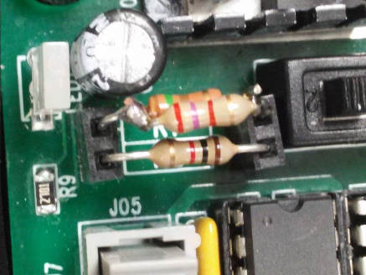The last area we considered was our output voltage. We broke this into two categories: less than 10V of output, or greater than 10V of output. Our criteria were penalties, speed, and ability to push block. At less than 10V, we would not acquire any penalties regarding our voltage output, but it also would not allow us as much speed and would decrease our ability to push the block. In the end, we decided that the penalties would be likely be more detrimental than the gain in speed, so we decided to try and stay at or under 10V. In order to achieve this approximate voltage goal, we used one 1,000 ohm and one 140 ohm resistor.

|  |  |  |  |
| --- | --- | --- | --- |
| Output Voltage | | | |
| Criteria | **Importance** | **>10V** | **<10V** |
| Penalties | 3 | -- | ++ |
| Speed Consequence | 2 | + | - |
| Ability To Push Block | 1 | + | - |
| Weighted Scores |  | -3 | 3 |
| Design Choice |  |  | X |

Our purchases for this project are listed in a chart below. All costs were split evenly among the five members of our group. Our purchases included a LEGO City 4 x 4 Off Roader, a miscellaneous set of extra LEGO pieces, two motors, resistors, eight 9V batteries, extra wheels, and a combination lock used to safely store all of the aforementioned components. All prices have been rounded to the nearest dollar. The total cost of all purchases was $110, which split between five people is $22 per person.

|  |  |  |
| --- | --- | --- |
| Budget | | |
| Item | **Price** | **Means of Purchase** |
| LEGO City 4 x 4 Off Roader | $20 | Retail (Walmart) |
| Misc. LEGO Pieces | $10 | Online (Amazon) |
| LEGO Motors (2 count) | $20 | Retail (AU Science Supply Store) |
| Resistors | $0 (Free) | Broun (AU Campus) |
| 9V Batteries (8 count) | $25 | Retail (Walmart) |
| Combination Lock | $5 | Retail (Walmart) |
| Exta Wheels (56x28mm, 4 count) | $30 | Online (Amazon) |
| TOTAL PRICE: | $110 |  |

After completing our car, the final stages of our preparation dealt mainly with running a practice course. Our driver was decided by the lowest average time, as well as the time available to practice for the race. After a number of attempts and ideas pertaining to the most precise route, we found that a “good” time in the race would be approximately between ten and twelve seconds. This is the time range that we were aiming for based on our tests, although we 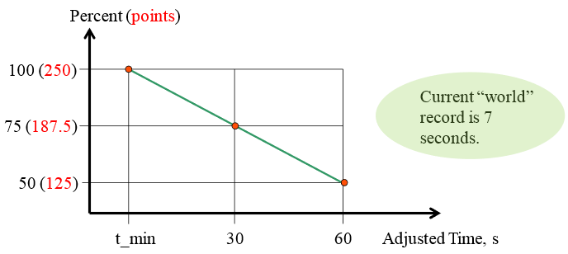considered the possibility of an excellent run and getting a lower time. In the race, we exceeded expectations and obtained a time of eight seconds, at least two seconds lower than what was expected and a three-way tie for second place. This time was mainly attributed to simply a well-controlled run with a perfect block-pushing angle. The car went through each gate smoothly and hit the block at a perfect perpendicular angle, essentially running itself through the finish line. The only other factor besides good control was a clean and dust-free floor. Layers of dust can reduce the car’s traction and speed, and since the floor was cleanly swept (and our tires freshly cleaned), this factor was eliminated. All in all, our timed run was a great success, and our car likely could not have attained a better time without serious revision.

**Conclusion**

Through comparative reasoning and experimentation, we were able to come up with the most effective build of our LEGO vehicle that we could conceive in the time allotted. The major design components – output voltage, wheel size, power supply, control strategy, car size, and intended course path – were each tested and analyzed in order for us to develop the best approach. Analysis of these key components allowed us to come up with the most effective and efficient design for our LEGO car.

Regarding our output voltage, we tried to get to 10.0 volts as closely as possible, using the appropriate resistor couple in order to reach this goal. We also concluded that it was best to use two 9 volt batteries for our voltage for the main purpose of maximizing output for each individual motor. Using relatively large front wheels with a diameter of approximately 56mm and a high-traction design, we curbed the possibility of failure to push the block while also guaranteeing a respectable speed. In order to hold all of the necessary components, we built a flat, square-like platform as a base in order to hold all of the components while still being sturdy. This would ensure practical effectiveness and avoidance of dismantling while also keeping the overall weight from being too heavy and negatively impacting the car’s speed. Because pushing the block was concluded to be paramount, we designed a front piece to better ensure that our car would have no trouble in pushing the block to the finish line.

These design decisions – all of which remain within the parameters of the task at hand – led us to construct an efficient and effective car that was able to complete the race in a reasonable amount of time while also maintaining practicality and flexibility.

**Appendix**

*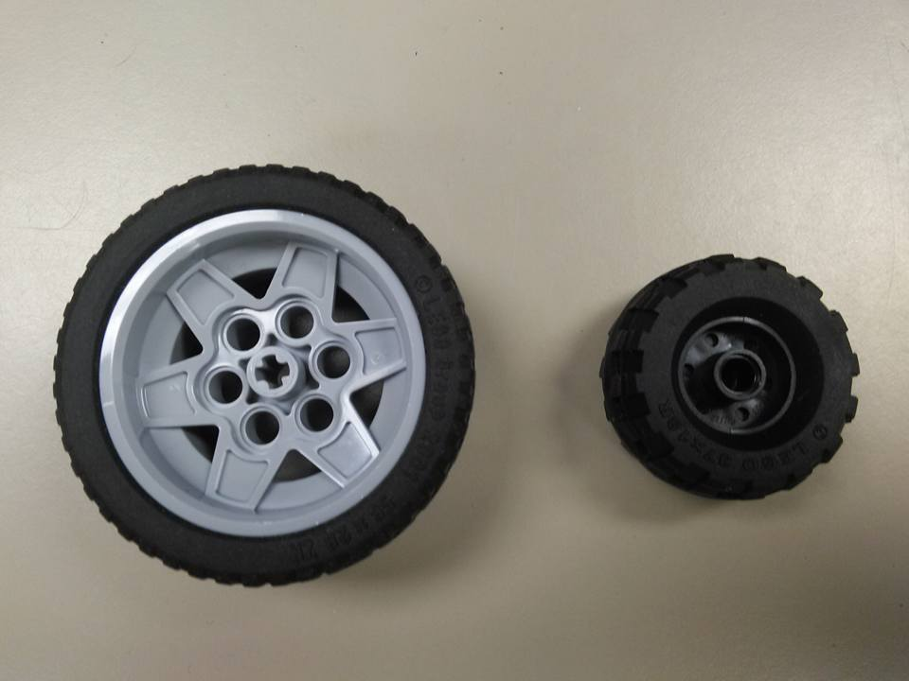Size comparison of wheels (56mm diameter vs. 37mm):*

*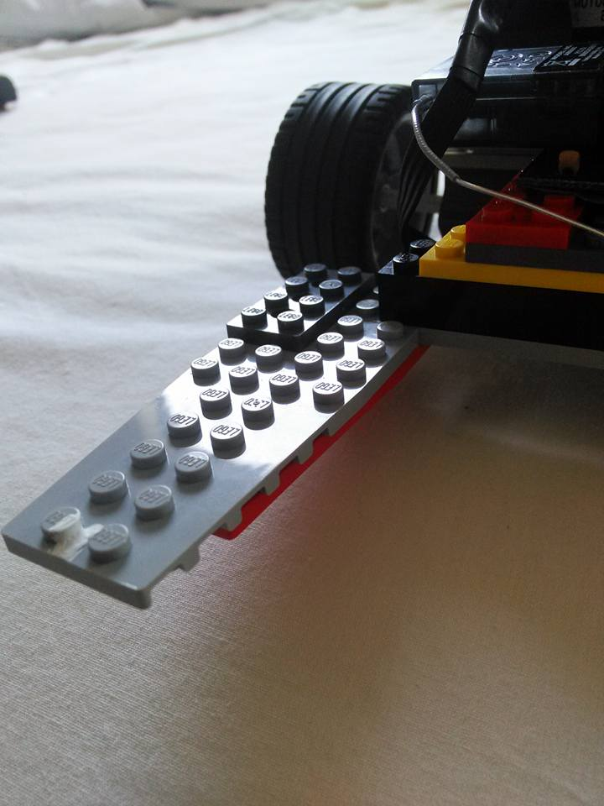Front piece used to push block and keep it stable:*

*Pictures of the final build:*

